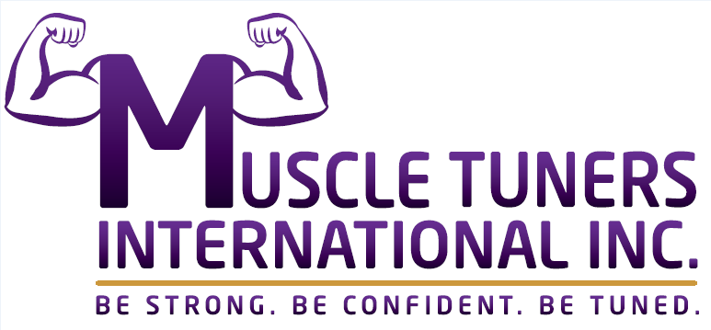
PRESS RELEASE
For more information:
Heather Phillips – MTI Inc. – heather@muscletuners.fit
Lainie Sevante’ Wulkan, Enlightened Audio & Sound
lainie@cinderconeworldwide.com
FOR IMMEDIATE RELEASE

CANADA BASED MUSCLE TUNERS INTERNATIONAL INC.
ANNOUNCE WORLWIDE RELEASE OF EDUCATIONAL MUSCLE MOTION SONGS

May 22, 2018, Kitchener, ON - As part of Muscle Tuners International Inc.’s ongoing commitment to teaching personal and sport trainers, physical therapists and other health & wellness practitioners, the protocol of “switching on” and “tuning up” muscles before working them to get faster results with clients, MTII company owners, Heather Phillips and Denise Cambiotti, both long time Kinesiology Instructors have added the Primary and Secondary Muscle Motion Songs to their portfolio as another key teaching asset to their current training tools taught via their online and in person Muscle Tuner™ Specialist Program.

The 52 Muscle Motion Song has been created with a very upbeat, musical pop tone to assist all students who are learning human anatomy with both a fun and easy way to remember the muscle groups. Whether one is studying kinesiology, nursing, massage, medicine or other types of human body education, the songs will become essential tools for learning and retaining the order and Range of Motion of the 52 muscles in their Program. MTII will release 3 songs: The Primary Muscle Motion Song, The Secondary Muscle Motion Song, the complete 52 and the MTII Instrumental Theme Song music. Song samples can be heard at the MTI Bandcamp Page.

As part of the continued due diligence in all the innovative, yet practical techniques Phillips and Cambiotti develop, the songs have already shown effective promise. “Research has shown that when we evaluate key muscles from our Muscle Tuner™ Specialist Program, we commonly find muscles switched off,” said Phillips and Cambiotti. “After our participants perform the muscle motions described in our songs, we recheck them and all show improvement! You should see people's faces when they feel their muscles working better!"

The digital releases will be available June 1st on all online outlets. They are being released by Florida, USA based, Enlightened Audio & Sound, an imprint of Cinder Cone Records.

Muscle Tuners International Inc. trains people how to switch-on and tune-up muscles using manual muscle testing and reflex activation so that people can observe better function and improved strength and flexibility in a single session. MTI Inc. envisions offering a satisfying career path and a value-add & up-level to professionals already working in the fitness & recovery industry.

